Title of Document
Student Name
24ECM05
2025-05-16
Table of Contents

1 Introduction
Let me first talk about the structure of the project, then I will talk about writing about it in the Quarto. The project should include following sections.
- Introduction
- Literature Review
- Data and Methodology
  - Data
  - Methodology
- Results Analysis
- Conclusion
- References
I am sharing sample papers to understand, what should go in these sections.

2 Writing in Quarto
Now let me introduce different procedures needed to complete the project in Qaurto.
- First YAML
In YAML, we include about the document information and formatting structure of the document. Here I have included bare minimum YAML, which will be sufficient to complete the project in a structured format.
- Inserting a link
To include a link, you have two options. One where you want to display the full link then write like this https://www.google.co.in/. Remember the link should be in between the <> if you want to show a text instead of a full link and hide the link behind the text. Then write like this. To go to Google, click on the word Google.
- Different formats of texts
To write a bold text, you have to the texts in between the symbols ** **, and to write italic texts, you have to write the texts in between the symbols *** ***.
- Bullet items and numbered items.
First, to create bullet items you can use the symbol * or -. You must give space after the symbol and also have space between one bullet item to another. To create a sub-bullet, you have to shift the next bullet item towards the right. For example, see this list.
- item1
- item2
  - sub-item1
  - sub-item2
- Numbered items
- item1
- item2
  - sub-item1
  - sub-item2
You may use the tab to create a sub-bullet(Use two tab spaces to create sub-numbered items).

3 Writing equations
There are two types of equations you may need to insert in the document. One is known as an inline equation, such as $y=a+b$. The second is known as Display equations, such as
$$y=α+βx$$
 Note
To write a display equation, use $$ sign at the beginning of the equation and at the end of the equation, and there should not be any space after the $$ sign and before the $$ sign.
To write a numbered equation, use a tag after the $$ sign at the end of the equation like this.
$$y=α+βx \left(1\right)$$
Note
The tag must be inside the curly bracket {} and start with #eq, and after - you can put any identification. For example, I have used the word one.
In quarto, we use LaTeX language to write mathematical symbols and equations. To see the full list of LaTeX code, click HERE.

4 Changing the colour of the text.
You change the colour of the text by using the command {style="color: red"}. To make the colour of the text blue, I have used {style="color: blue"}. Similarly, to use the color of the text red, I have used {style="color: red"}. The specific text of which you want to change the colour must be within [] and followed by the style.

5 Inserting code
To insert the code chunk (group of codes), you have to use the back quote (`), just below the twiddle/tilde (~) symbol. To insert a code chunk, in the beginning, put three *back quote(```) symbols and at the end also put three back quote(```) symbols.

5.1 Some examples
Here we will import the data for further analysis.
Note
Another and easiest way to insert code chunk is to switch to the visual editor and from the insert tab click on the executable cell or use shortcut keys Ctrl+Alt+I.
In the above code chunk use echo: false will make sure that code is not printed in the document. However, eval: true makes this code executable that is data will be imported and stored in dataframe named data.
Lets examine the data by using code head().
Year HI SID
1 1990 0.207 0.793
2 1991 0.231 0.769
3 1992 0.220 0.780
The results will be printed in the document.
Now lets make line graph of these variables.
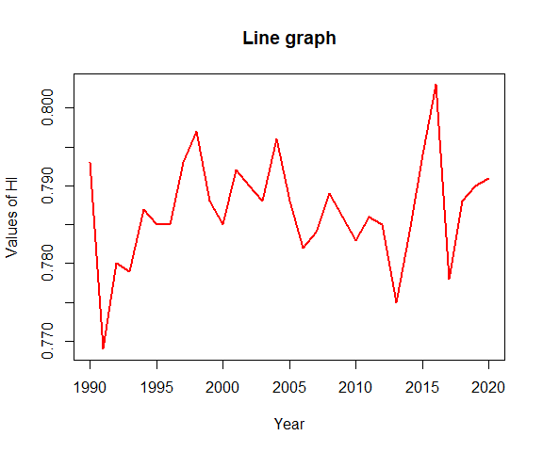
Figure 1: A Figure
Here in the above code chunk fig-width and fig-height is for the width and height of the figure respectively. fig-align is for the alignment of figure, which is in center of the document width. Similarly fig-caption and fig-cap-location is respectively for the caption of the figure and position of caption. Here option label makes the figure cross-referenceable. Here we cross-reference the above figure like this, the Figure 1 shows overtime growth of HI.
Note
First to lable the figure command must start with fig and then after - name the graph/plot. For example here name is line-plot. Then use @ followed by fig-line-plot to cross-reference the figure.
Warning: package 'psych' was built under R version 4.4.1
Table 1: Descriptive Statistics
 | vars | n | mean | sd | skew | kurtosis | se
HI | 1 | 31 | 0.213129 | 0.0067416 | 0.2145743 | 0.5424833 | 0.0012108
SID | 2 | 31 | 0.786871 | 0.0067416 | -0.2145743 | 0.5424833 | 0.0012108

Here kable is to make the table in the document. You can cross-reference the table as Table 1.

6 Final words
This is a sample, you can explore further for the other options. You may find the complete list of option HERE.
Note
Remaining formatting, you may do in the generated word file also.

